TeleJukebox
(the musical telephone)



Fw and hw design by : Jan Derogee
PCB design and testing : Paul Hulsebosch
Original idea by : Leo Willems

Introduction
The TeleJukebox is a project based on the concepts of the Wonderfoon and Arduinofoon. The project called "Wonderfoon" was initially created by Leo Willems but gradually this project evolved. https://www.gelderlander.nl/nijmegen/wonderfoon-laat-dementerende-ouderen-luisteren-naar-liedjes-van-vroeger~adb0f781/?referrer=https://www.google.com/ There is also one iteration of the Wonderfoon, which is called the "Arduinofoon", this is a much more simplified version of the Wonderfoon, but it still requires the phone to be heavily modified.
https://www.repaircafehengelo.nl/arduinofoon/ The TeleJukebox was designed to be easy to build without damaging the rotary dial phone.

The Wonderfoon project came to the attention of my wife when she saw it on Dutch television:
https://nos.nl/video/2299835-de-wonderfoon-voor-dementerende-ouderen.html
It showed how elderly people loved the sight of an old-skool rotary telephone and their amazement when it played very familiar songs of their past. This project seemed to be focused on people who have Alzheimer.
Now because I'm a technician, so my wife knows I like to tinker with old stuff. And considering that some time before I've did a project also involving a rotary phone, it made sense that she asked me if I could build such a phone.
She already did a quick search on the internet that brought her to the website:
http://www.wonderfoon.nl That webpage had instructions on how you could make such a phone. But although I liked the project, I didn't like the requirement of dismanteling a perfectly fine phone. If making a wonderfoon would mean dismanteling/damaging/ruining/destroying the great wonder of 1965 technology… forever, then I do not want to have to do anything with that. So I figured that if I was to make such a phone, then I has to be made in a way that the old phone can be used in an unmodified form, or at least in a form where it can be brought back to it's original state. I was also a bit surprised by the Wonderfoon design which (in my eyes) seemed overly complicated for the task it needed to do, sure it doesn't matter for those who use it. But a complicated design doesn't help the volunteers who assemble these devices in their spare time. So if I can make it cheap and easy, then these people will be happy too and they can make more of these devices in less time for less money and effectively make more elderly people happy. Although at that time I was to make only one, looking ahead when making something new never hurts, and I'm glad I did.
This resulted in a design called the TeleJukebox. I named it the TeleJukebox, to distinguish my project from the Wonderfoon which otherwise would cause a lot of confusion. I also figured that the name TeleJukebox would be better understood by anyone who doesn't speak Dutch, important as I wanted to put my design online. This way, in the spirit of open-source-design, anyone can use it.

Table of Contents
1 How to use a rotary dial phone 4
1.1 What is a rotary dial phone 4
1.2 How to use it 4
2 Power supply 5
3 Setup 6
3.1 SD-card 6
3.2 TeleJukebox settings 8
3.2.1 Volume (default = 100%) 8
3.2.2 Music folder (default = 1) 8
3.2.3 Easter egg mode (default = ON) 8
4 How to use 9
4.1 First time use 9
4.2 Normal use 9
4.3 Random 9
4.4 Dialing emergency numbers 10
5 Trouble shooting 11
6 Easter eggs 13
7 Telejukebox design 14

How to use a rotary dial phone

What is a rotary dial phone
Rotary dial phones are the earliest user controlled phones to be mass produced. Prior to the rotary phone a user would pick up the phone, wait for the operator to answer and then tell the operator who they wanted to be connected with. With the rotary dial (pulse dialing), the user was able to make the connection themselves and therefore was no longer dependent on the speed/skill and presence of the previously used operator. This allowed the user to dial freely and at any time of day, allowing for quicker and more convenient connection to the people they wanted to speak with. This wonder of progress began to exist in 1919 and was to be slowly replaced by push buttons (tone dialing) since 1963. However tone dialing required much more expensive phones and stations. Tone dialing became truly possible (widely accepted by the public) somewhere in the early 1990's.

How to use it
The rotary dial phone isn't difficult to use, however it may be confusing for some people who never encountered this dialing system. Below is a wonderful set of images from WikiHow that shows you how to use this system.

First pick up the handpiece/receiver, and hold it against your ear, the cord is on the microphone side, which you should hold near your mouth while speaking. The if the first number of the telephone number you want to call is 5, place your finger in the hole with the number 5 and turn the disc, using your finger clockwise towards the fingerstop.
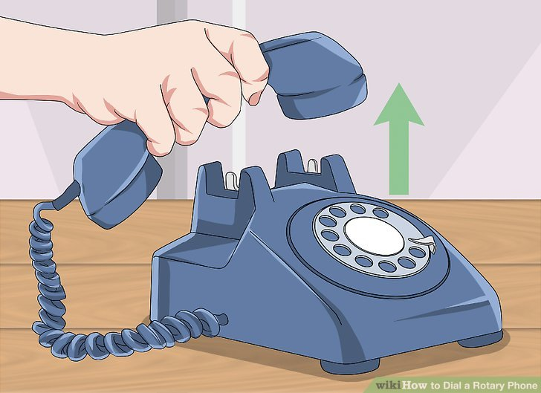

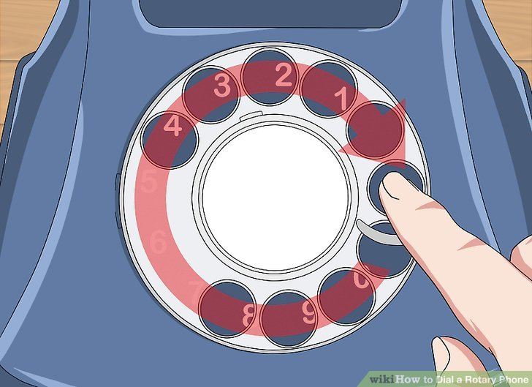
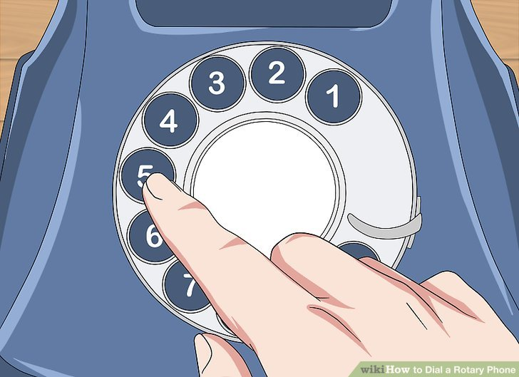
When your finger hits the fingerstop, pullback your finger from the disc, which will now turn back to it's original position making a soft clicking sound. When the disc stops turning dial the other numbers in the same way. When all numbers are dialed the connection is made and you may styart your conversation. Hang up the handpiece/receiver on the “hook” when your are finished.
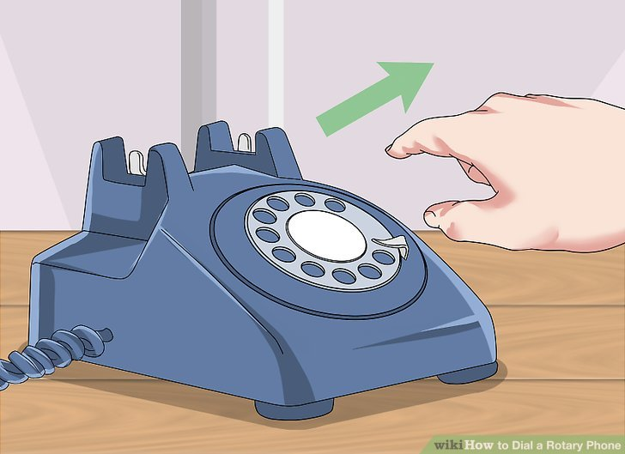
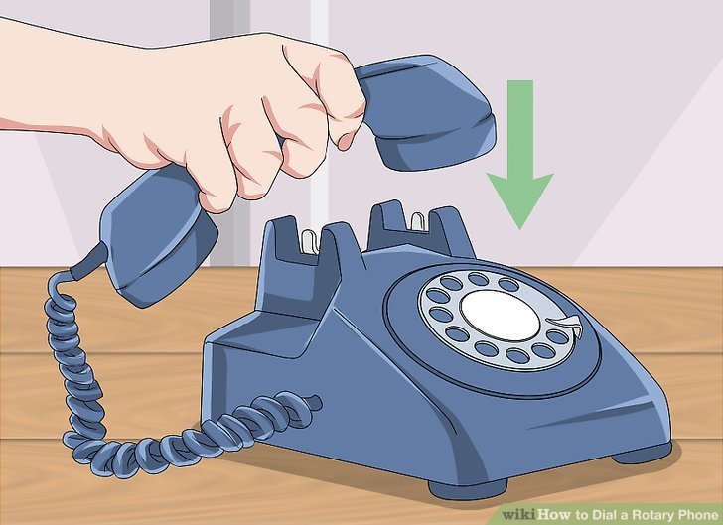
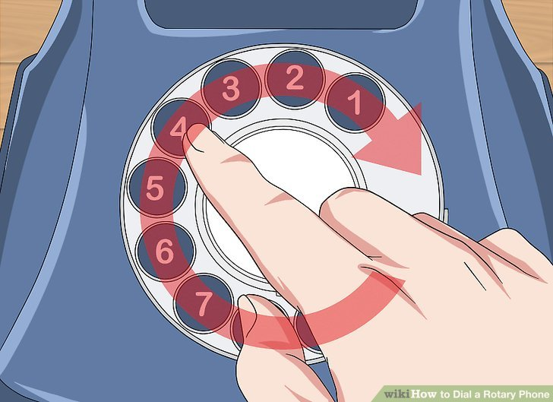

Power supply
The TeleJukebox is powered by a USB-power supply. Some people may call this a phone charger, as these devices are widely sold as power supplies for charging you telephone. An image of such a power supply can be seen below, but these come in many shapes, colors and sizes.
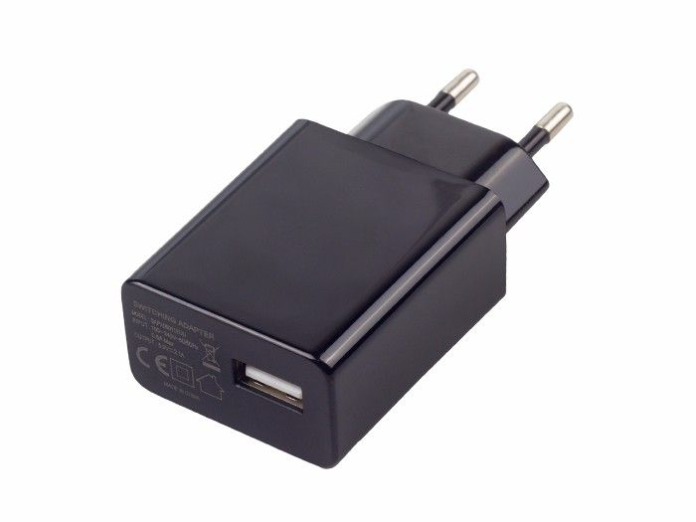
Make sure that you use a decent 5V/1A (or 2A) power supply in combination with a decent low resistance USB cable for connecting the power supply to the TeleJukebox.
However, the USB connector on the TeleJukebox is not only used for power, it actually serves two functions. Because instead of connecting the TeleJukebox straight to a simple 5V power supply, you can also connect it directly to the USB port of your PC, which then allows you to configure the SD-card.

TeleJukebox powered by 5V powersupply
The TeleJukebox operates normally.

TeleJukebox powered by PC USB port
The TeleJukebox operates like a USB card reader, the user will see the contents of the SD-card. In this mode the TeleJukebox cannot be used for playing back audio files! This means that in this situation the connected rotary dial phone seems to be non-functional.

Setup
The TeleJukebox requires an SD-card to be properly configured with a set of MP3 files. And with only 3 settings: Volume (10-100%), Music folder (1-10) and Easter egg mode (on-off) to be set.

SD-card
The TeleJukebox uses an MP3 player which uses an SD_card to hold the music and spoken instructions, the SD-card should contain the following folders:
Root:
01 This folder contains the MP3 files to be played when folder selection is 1
02 This folder contains the MP3 files to be played when folder selection is 2
03 This folder contains the MP3 files to be played when folder selection is 3
04 This folder contains the MP3 files to be played when folder selection is 4
05 This folder contains the MP3 files to be played when folder selection is 5
06 This folder contains the MP3 files to be played when folder selection is 6
07 This folder contains the MP3 files to be played when folder selection is 7
08 This folder contains the MP3 files to be played when folder selection is 8
09 This folder contains the MP3 files to be played when folder selection is 9
10 This folder contains the MP3 files to be played when folder selection is 10
90 System audio folder (dial tone, text messages for menu, etc.)
Note: make sure that folder 90 contains the speech files for the desired language
99 Easter egg audio folder (easter egg related songs and messages)

Folder 01 .. 10
000-<name of song>.mp3 = this is the song that will be played when the user dials a 0
001-<name of song>.mp3 = this is the song that will be played when the user dials a 1
002-<name of song>.mp3 = this is the song that will be played when the user dials a 2
003-<name of song>.mp3 = this is the song that will be played when the user dials a 3
004-<name of song>.mp3 = this is the song that will be played when the user dials a 4
005-<name of song>.mp3 = this is the song that will be played when the user dials a 5
006-<name of song>.mp3 = this is the song that will be played when the user dials a 6
007-<name of song>.mp3 = this is the song that will be played when the user dials a 7
008-<name of song>.mp3 = this is the song that will be played when the user dials a 8
009-<name of song>.mp3 = this is the song that will be played when the user dials a 9
Regarding the filenames of the MP3 files, the TeleJukebox only cares about the first 3 characters in the filename, this needs to be a number, after that number there can be any text you'd like, which may help in identifying the songs. This means that the filename of a song in music folder 1 to 10 can be as simple as:
001.MP3
or a little bit more practical like:
001- Queen – love of my live.MP3

After placing all the files and folders onto the SD-cad, make sure to safely remove it from the PC, this to make sure that the filesystem of the card will not be corrupted and may cause problems later.

TeleJukebox settings
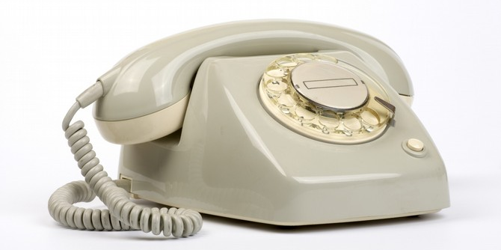
The TeleJukebox has 3 settings which can be configured by using the dial on the phone when the phone is in settings mode. To put the phone into settings mode hold down the button (indicated by the dotted red circle) while picking up the handpiece, hold speaker part of the handpiece to your ear and release the button, you will now hear a menu. Let the voice of the spoken menu guide you through the menu. But only dial a number when the voice indicates you to do so, everything dialed before this moment will be ignored.
If you do not have a phone with such a front side button or if you do not whish to use this functionality, then you can also dial the number 738. Make sure to dial this number without hesitation, because there is a small timeout of 5 seconds on each dialed digit. This in order to prevent that people accidentally dial the settings mode, as otherwise could happen when a person listens to song 7 then song 3 and then song 8. The number 738 was chosen because the S=7, E=3, T=8 (think of a phone letters underneath the numbers on it's dial).

Volume (default = 100%)
It is best to set the volume to 100%, simply because most elderly people have a bad hearing. If you change the volume setting then it might be too low of a volume to hear properly. The volume settings is only used for playback of the music. The volume of the configuration menu is always maximum, this because it would be very annoying if you could not hear the menu that you need to hear in order to adjust the volume.

Music folder (default = 1)
To allow for multiple playlists, up to 10 music folders are supported.
For instance, put Summertime songs in music folder 1, Wintertime songs in music folder 2, Holiday songs in folder 3 and birthday songs in folder 4, etc. Just use you imagination. The whole idea of having 10 different music folders is that the user only needs to dial a single number 1,2,3,4,5,6,7,8,9 or 0 and nothing else. It's up to the caretaker to setup the correct playlist.

Easter egg mode (default = ON)
The easter egg mode is nothing more then a small gimmick, a little joke from the programmer. An easter egg can be triggered by dialing a very specific number sequence. If you dialed the correct sequence you can hear something special. But because not everyone shares the same sense of humor or because sometimes it isn't appropriate to have easter egg to be played, this mode can be switched off.

How to use

First time use
When the TeleJukebox is properly configured then it can be powered on by applying power to the device. The first time the user picks up the handpiece on hold the speaker to it's ear, the current settings are spoken. This way the person installing the device can check if it is set up properly without the need of accessing the menu. This is only the first time after power-up, if this message needs to be repeated, then disconnect power for 30 seconds, and try again. If this message is not desired, put down the handpiece back onto the telephone for 1 second or longer and the playback of the message stops.

Normal use
Normally the TeleJukebox is permanently powered, allowing the users to use the device whenever they want. All a user needs to do is pickup the handpiece, hold the handpiece to it's ear, listen for the dialtone and dial a number from 0 to 9 and the music will play. No further dialing is required. The played music is depends on the music folder setting.
For example: if the music folder setting is music folder 1, then if the user dials a 5 then the MP3 file named 005.MP3 from folder 01 will be played.
If the user dials another number while the music is playing nothing will happen, the music keeps on playing.
When the music is finished the user hears the dialtone and can immediately select a new song, there is no need to put down the handpiece first.
If the user doesn't like the song that's being played then put down the handpiece onto the telephone for 1 second or longer and the playback of the song stops. Then you can pick it up again and select a different song.

Random
The button on the front side of the telephone (see the button indicated by a dotted red circle) can be used to randomly play a song from the current selected music folder.
The user needs to pick up the handpiece from the telephone and hold the handpiece to it's ear. Then push the button and a randomly chosen song from the currently selected music folder will be played. When this song ends a new random song will be automatically started. This allows for longer periods of musical playback which is especially useful for situations where users can't dial the number(s) themselves and are fully dependent on caretakers to do this for them. Now the caretaker only needs to push one button and playback is endless.
If a random song that's played back isn't preferred, then press the button once more to play the next random song.

Dialing emergency numbers
If a user dials: 112, 911 or 0908844 then a message is being played indicating that this phone is not suited for dialing emergency numbers and that a different phone should be used. Now although it should be obvious that this old phone isn't connected to the telephone network, some people might want to use in case of a panic/emergency situation. Therefore playing this message might help in saving precious time

Trouble shooting
In some cases when you try to use the phone, it doesn't work as expected. Things may happen and things may fail. Below are some a few suggestions about what could be the case and how to solve it.
The TeleJukebox doesn't work of makes funny noises:
Make sure you are using a decent power supply and cable. Although any 5V/1A power supply should work problems may arise if the USB cable between the power supply and TeleJukebox is too cheap. Cheap cables tend to have very thin wires, resulting in large resistance, effectively reducing the power the TeleJukebox. Therefore always use a high quality low resistance USB cable to power the TeleJukebox. Keep in mind that short thick wires are better then small thin ones.

The TeleJukebox doesn't work:
Check if the phones is in good working condition. Make sure that the wiring of the phone and handpiece are not damaged. Make sure that the contacts inside the phone are properly functioning and that the microphone is shorted as described above. If the phone works correctly then a resistance of approx 50 Ohm should be measured between pin A(red wire) and B(blue wire) of the phones connector. If this isn't the value you are measuring then double check if you have applied the short properly and double check if the contacts inside the phone switch reliably. The contacts inside the phone can sometimes be very corroded, cleaning it with a piece of paper (acting like very mild sandpaper) can do wonders. The contacts directly underneath the hook mechanisms are the most likely ones to need attention. The contacts of the dial are easily checked by measuring between A and B of the phones connector. When dialing the resistance will change rapdidly between OPEN and SHORT. Dial a zero on the phone and then slow down the dial while it rotates counter clockwise) to it's rest position. You may stop the dial at any specific point tho do a steady measurent. Keep in mind that the dial pulse is only generated while the dial is moving counter clockwise.

The TeleJukebox doesn't play songs:
Make sure that the SD-card is properly configured and that the selected folder contains MP3 music files. It is important to have only ten MP3 files in each music related folder. And that these files are named 001.MP3 to 010.MP3

The TeleJukebox plays parts of everything
The SD-card might have a corrupted filesystem, it may not have been properly removed from the PC after configuration. Remove the SD-card from the TeleJukebox, plcae it into a PC, format the SD-card and place all the required files and folders onto the card. Then safely remove the SD-card from the PC and insert it into the TeleJukebox. It may feel good to know that the TeleJukebox itself doesn't do any writes to the SD-card, therefore it cannot corrupt the filesystem.
The TeleJukebox doesn't work:
Make sure that the microphone is shorted, place a piece of aluminum foil inside the microphone to short the connections. But a Better way would be to short the microphone connections inside the terminal block on the bottom of the phone. Also check if the wiring of the phone is not damaged.
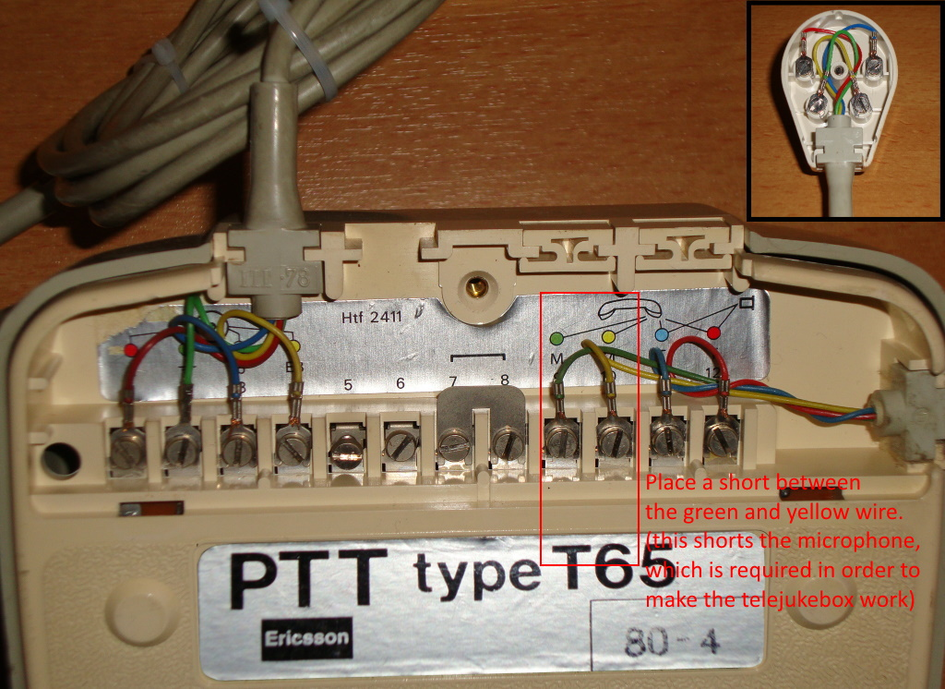

Easter eggs
Easter eggs are little jokes put into a device by the programmer during development of the product. Sometimes an easter egg is a way of putting a name tag into the code, allowing the programmer to claim the software to be his/hers in a later stage. Sometimes an easter egg allows for additional functionality in the form of a small game. Sometimes an easter egg is just an homage to something historical or sentimental. But in all cases an easter egg is supposed to be a harmless little joke created by using the otherwise unused space in a programs memory.
Normally, easter eggs are to be hidden and not shown in a manual, perhaps a small hint but never directly as printed here. The reason why it is printed here is simple… nobody would notice this functionality otherwise. And what is the fun in a joke if nobody notices it?
And this device has an easter egg too. Just a few number sequences need to be dialed to get a reminder of something from the past.
Here are some examples of easter eggs:
Dial 002 to hear something about time (since 002 was the old Dutch number for time information)
Dial 003 to hear something about the weather (since 003 was the old Dutch number for the weather information service).
Dial 008 to hear something about number information service (since 008 was the old Dutch number for the telephone related information service).
Dial 1945 to hear Blondie sing, 1945 = year of birth of Deborah Harry
Dial 1947 to hear Andre van Duin sing, 1947 = year of birth of Adrianus Marinus Kyvon
Dial 1950 to hear Stevie Wonder singe, 1950 = year of birth of Stevie Wonder

Attention:
Easter egg number sequences are to be dialed without hesitation, because there is a small timeout of 5 seconds on each dialed digit. This in order to prevent that people accidentally trigger an easter egg by listening to a sequence of songs that consists of the same number sequence of an easter egg.

Telejukebox design
The TeleJukebox uses an Arduino Pro Micro and a simple $1 MP3 player. An optocoupler some resistors, capacitors and wires tie everything together. But most importantly, it DOES NOT require any permanent modification to the phone itself. All electronics are to be placed inside a small box to which the telephone connects through it's existing PTT phone connector.

The Arduino Pro Micro was choosen because of it's small size and cost. And because of it's easy way of programming. No special tools (other then a USB micro cable and a PC with the Arduino IDE on it) are required.

